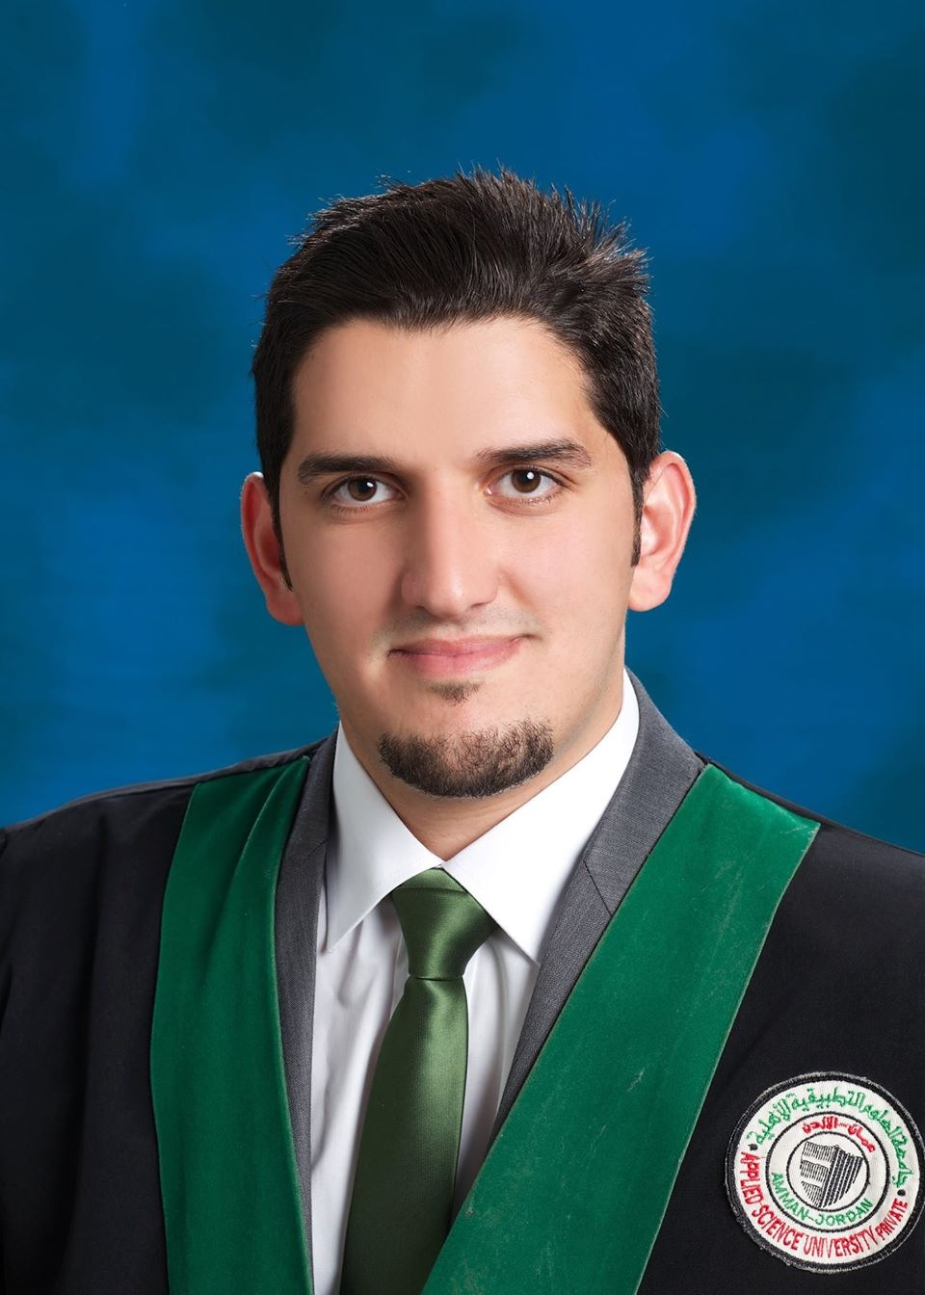

Ahmad Mahmoud Yacoub

CONTACT DETAILE:

- Mobile: +965-66589644-66595777 - 99708422
- Home : + 965- 25623332
- Email:ahmad-_-yacoub@hotmail.com
Career Objective

Looking forward to having a Junior position in Marketing field within a professional environment, and achieving collective growth to the organization as well as to myself.

Experience Record

- Gulf Bank – Sales Officer
From Mar 2016 until now

- Trafalgar Company– AIGNAR (Sales)
From Jun 2015 until Feb 2016

- Kuwait Edafah Company (Sales Executive) ,
From 14th Feb 2015 until Jun 2015

- Trainer in credit Rating & Collection Company (Marketing) ,
From 15th September 2013 until 15th of Oct 2013

Responsibilities:
- Managing Customer Queries
- Preparing Internal and external orders.
- Preparing correspondence and reports.
- Call centers Agent.
- Telemarketing.
- Sales & Services contracts Marketing

- LOYAC Summer Program (Admin) From June 2009 - September 2009
Responsibilities:
- Dealing with clients.
- Reply emails.
- Processing orders.
- Managing Administration.

Academic Education
- Applied Science Private University in Jordan – (Marketing)
From 2009 till June 2014

- Training Diploma in Computer Applications,
  - M.S. Windows & Dos.
  - Microsoft Office.
  - M.S. FoxPro Applications.

- Higher Secondary, Al Ekhlas School, Kuwait, 2009- 2009.

